New York I Love You!
Statuia Libertății – Wall Street – Memorialul 9/11 – Union Square - Soho – Chinatown – Little Italy - Central Park – Grand Central Station – Chrysler Building - Centrul Rockefeller - Fifth Avenue - Broadway – Times Square - Empire State Building - Brooklyn
995 €
5 nopți/ 7 zile

date de plecare
- 23.05, 20.06.2019

TARIFUL INCLUDE
- 5 nopți cazare la hotel 4* în centrul New York-ului, Manhattan
- 5 mic dejunuri
- Bilet avion București – New York – București, cu compania Lufthansa
- Transfer aeroport–hotel-aeroport
- Vizite ghidate conform descrierii pentru toate zilele
- Tururi pietonale zilnice și de autocar cu ghid local
- Ghid însoțitor din București pentru întreaga perioadă
- Manevrarea bagajelor la hotel, bacșiș ghid local și șoferi

Tariful nu include
- Taxele de aeroport pentru zborurile internaționale, taxe oraș și taxe hoteliere: 475 €/ persoană
- Taxa și formalitățile de obținere a vizei de SUA: 160 $/ persoană
- Asigurarea medicală de călătorie și asigurarea storno (nu sunt obligatorii, însă vă recomandăm să le încheiați)
- Intrările la obiectivele turistice
- Biletul de feribot spre Statuia Libertății (aprox. $25)
- Cheltuieli personale sau alte bacșișuri

Bine de știut
- Plecările se fac de pe aeroportul din București, ora 06:10; sosire Frankfurt, ora 07:40 (durată zbor 2 ore și 30 min); plecare din Frankfurt, ora 11:00; sosire New York, aeroportul JFK, ora locală 13:40 (durată zbor 8 ore și 40 min).
- La întoarcere, de pe aeroportul JFK, New York, ora 21:55; sosire Frankfurt, ora 11:35 (durată zbor 7 ore și 40 min); plecare din Frankfurt, ora 14:25; sosire București, ora 17:40, (durată zbor 2 ore și 15 min).
- Zborul are escală în Frankfurt la dus și în Viena la retur.
- Turiștii se vor prezenta la aeroport cu 2.5 ore mai devreme față de orele de plecare menționate.
- Fiecare pasager are inclus maxim un bagaj de cală, cu o greutate de până la 23 kg și un bagaj de mână care nu poate depăși 8 kg.
- Avansul la înscriere este de 30%.
- Plata se face în euro sau în lei (la cursul BNR din ziua respectivă + 2%).
- Deși se fac toate eforturile pentru a opera tururile cum sunt prezentate, în unele ocazii poate fi necesar să facem modificări la traseu sau ordinea obiectivelor din itinerar.
- Ordinea vizitelor din fiecare zi a obiectivelor turistice se poate modifica, cu asigurarea vizitării tuturor obiectivelor incluse.
- Grupul minim pentru a se organiza acest program este de 35 persoane.
- În SUA tensiunea standard din rețea este de 110 V, fiind necesar un adaptor pentru încărcarea aparatelor electice europene. Prizele au doi pini plați.
- New York se află pe fusul orar Eastern Standard Time, cu 7 ore mai puțin ca în România.

ACTE șI CONDIțII PENTRU VIZA SUA
- Pentru turiștii care nu dețin viza de SUA pe pașaport, se va aplica pentru viza de grup. În acest caz, fiecare turist trebuie să achite o taxă de solicitare a vizei, în valoare de $160.
- Taxa aferentă solicitări de viză nu este rambursabilă şi nici nu poate fi transferată către o altă persoană. Taxa de solicitare a vizei se va achita indiferent dacă viza este sau nu eliberată.
- Viza turistică pentru Statele Unite ale Americii se eliberează la Ambasada SUA din România.
- Pentru călătoria în SUA este necesar pașaportul simplu sau electronic valabil minim 6 luni de la data terminării călătoriei cu viza aplicată.
- Prezența personală la Ambasada SUA este mecesară, în vederea susținerii unui interviu (la data și ora comunicate de agenție).
- Documente suplimentare vor fii solicitate de către agenție în vederea obținerii vizei de SUA, inclusiv o fotografie digitală făcută în ultimele şase luni.
- Termenul limită de încriere și transmitere a documentelor pentru visa de grup este cu aproximativ o lună înainte de data de plecare.
- După acestă dată, se poate solicita eliberarea vizei în regim de urgenţă, caz în care turistul trebuie să-şi depună cererea individual și să programeze interviul individual, la Ambasada SUA.

Program
"New York I love you" nu e doar o metaforă, e sentimentul pe care îl trăiești din prima clipă când pășești pe străzile celui mai cosmopolit oraș din lume. Abia după ce te-ai plimbat pe bulevardele cu clădiri ce zgârie norii și oameni din toate colțurile globului, abia după ce ai văzut Manhattan-ul sclipitor, ai urcat pe Empire State Building și ai savurat o cafea în Central Park, abia atunci simți că ai devenit cu adevărat călător. Pentru că odată ce vezi New York-ul, te va lăsa cu răsuflarea tăiată de atâta frumusețe și cu gândul c-ai văzut tot ceea ce merita cu adevărat văzut.

- Ziua 1: București – New York City
Zbor dis de dimineață din București. La prânz, sosire pe aeroportul JFK și transfer la un hotel din centrul New York-ului, în Manhattan, unde petrecem următoarele 5 nopți. Timp liber la dispoziție pentru acomodarea la noul fus orar. Întâlnire pe seară cu ghidul însoțitor pentru o introducere în geografia, obiceiurile și cultura New Yorkului. Veți obține informații despre activitățile recomandate și veți avea posibilitatea de a vă familiariza cu harta orașului. New Yorkul este un loc minunat pentru mersul pe jos, foarte simplu de navigat și cu un sistem excelent de metrouri.

- Ziua 2: Statuia Libertății – Batery Park - Wall Street – One World Trade Center – Memorialul 9/11 – High Line
După micul dejun, vizităm Lower Manhattan, cea mai istorică și mai veche parte a orașului. Ne urcăm de dimineață în feribotul care duce spre Statuia Libertății, cel mai cunoscut reper din New York. La întoarcere, într-un tur pietonal, descoperim obiective precum Wall Street, poate una dintre cele mai faimoase străzi din lume, Bursa din New York, Trump Building și un muzeu virtual de zgârie-nori. Vizităm site-ul unde se ridicau în trecut Turnurile Gemene (Ground Zero). Memorialul, care încorporeză amprentele turnurilor gemene, căzute la 11 septembrie 2001, a fost inaugurat la 10 ani după atacuri. Astăzi, strălucitorul One World Trade Center, cea mai înaltă clădire din emisfera vestică (cu o înălțime de 541 m) se ridică în mijlocul perimetrului, iar memorialul din jurul său oferă un loc liniștit de reflecție și omagiu. Pe seară puteți opta pentru o vizită la Chelsea Market și o plimbare pe inovatoarea promenadă High Line. Un triumf răsunător al reînnoirii urbane, High Line este fără îndoială, cel mai mândru testament al New York-ului pentru efervescența continuă de a transforma vestigiile cicatrizante din trecutul industrial al orașului în spații plăcute. Odată un traseu de tren elevat, care șerpuia între abatoare și locuințe sărăcăcioase, High Line este astăzi o bijuterie de spațiu verde, care a acționat ca un adevărat magnet imobiliar, atrăgând în cartier arhitecți din lumea întreagă pentru a crea reședințe minunate.
- Ziua 3: Tur panoramic cu autocarul din Downtown în Uptown
Din confortul unei autocar și cu un ghid turistic local, care va oferi o perspectivă asupra a ceea ce înseamnă a trăi în New York, vom obține o imagine de ansamblu asupra celui mai magnific oraș din lume! Din Downtown în Uptown, pe un traseu care bifează unele dintre reperele orașului, vom vedea: Harlem, Catedrala Sf. Ioan cel Divin, Parcul Central, Centrul Lincoln, Carnegie Hall, Națiunile Unite, Clădirea Empire State, Union Square, Clădirea Flatiron (primul zgârie-nori adevărat din New York), Bulevardul Broadway (sinonim cu strălucire, eleganță, teatre, spectacole , piese muzicale și divertisment) și multe altele. Apoi vom face o incursiune pietonală prin cartierele centrale ale Manhatanului: Little Italy, Chinatown, Greenwich Village și SoHo, fiecare cu personalitatea și farmecul lor.

- Ziua 4: Central Park – Grand Central Station - Chrysler Building - Centrul Rockefeller - Biblioteca Publică – Fifth Avenue – Times Square
Petrecem dimineața de astăzi explorând minunile Central Park-ului. Cercetăm Zabar’s, celebru printre newyorkezi și un adevărat rai pentru iubitorii de delicatese, de unde putem lua provizii pentru un picnic în parc. Admirăm pe exterior clădirea Muzeului Guggenheim, proiectată de Frank Lloyd Wright, Muzeul Metropolitan de Artă și multe minuni arhitectonice de pe Fifth Avenue. După amiază este momentul să descoperim alte repere inovatoare ale orașului: Centrul Rockefeller (piesa centrală a Manhattanului), Catedrala Sf. Patrick, Biblioteca Publică, Chrysler Building (cel mai frumos zgârie-nori dintre toate, un ac argintiu în stil Art deco, finalizat în 1930) și Grand Central Station. La apus ne bucurăm de reclamele luminoase și atmosfera din Times Square, “intersecția lumii”. La terminarea turului, puteți încheia ziua cu o panoramă perfectă a orașului, cu toate luminile sale strălucitoare, de la ultimul etaj din Empire State Building sau al clădirii Rockefeller Center.

- Ziua 5: Brooklyn
Dacă Brooklyn ar fi propriul oraș, ar fi al patrulea ca mărime din SUA, găzduind mai mult de 2,6 milioane de oameni. Începem ziua cu o plimbare de-a lungul zonei pietonale a Podului Brooklyn, o siluetă legendară pe orizontul New York-ului și un exemplu fascinant de inginerie de sec. XIX. Aici vom deveni martorii unor imagini incredibile oferite de orizontul Manhattan-ului și peisajul urban din Brooklyn. O instituție brooklyneză, Grimaldi’s Pizzeria este o oprire obligatorie. Ne plimbăm prin Brooklyn Heights, o zonă atrăgătoare cu case din piatră roșiatică, din sec. XIX și străzi pitorești, îndrăgite de scriitori și pictori. Apoi ne îndreptăm spre promenada de pe malul East River, în Brooklyn Bridge Park. De aici Manhattanul și Statuia Libertății sunt numai bune de fotografiat.

- Ziua 6: New York – Frankfurt – București
După micul dejun, bucurați-vă de timp liber pentru cumpărături la Macy’s, cel mai mare magazin din lume, la Century 21, cel mai bun magazin cu haine de designer la reducere sau descoperiți buticurile elegante din SoHo, Fifth Avenue sau Madison Avenue. New York este pur și simplu una dintre cele mai bune destinații de cumpărături de pe planetă. Chiar dacă nu cumpărați produsele, le puteți admira în vitrinele frumos decorate, ceea ce în acest oraș este o activitate în sine. Sau puteți opta pentru o vizită într-unul dintre faimoasele muzee. MoMA, Muzeul Metropolitan de Artă sau Neue Galerie se mândresc cu cele mai bune colecții de artă din lume. Apoi ne vom lua la revedere de la New York, cu amintiri care să dureze o viață. Transfer la aeroport dupa-amiază și sosire în București în data de 9 mai.

Experiențe unice
- Spectacole
Când vorbesc despre New York, majoritatea turiștilor se gândesc la Broadway și pe bună dreptate. New Yorkul este o adevărată Mecca a teatrului încă de la începutul sec. XX. Pentru o experiență memorabilă, vizionați un show pe Broadway, balet la Centrul Lincoln sau reprezentații gratuite ale piselor lui Shakespeare în Central Park. Teatrele mari sunt concentrate în zona Times Square. Biletele pentru piesele cunoscute trebuie rezervate din timp. Biletele de teatru la reducere de până la 50% pentru reprezentațiile din aceași zi pot fi achiziționate de la TKTS Times Square.

- Artă
New Yorkul respiră artă atât prin marile muzee – MET, MoMA, Guggenheim și Frick, cât și prin galeriile din Chelsea. MoMA este destinația pentru capodopere precum Noapte înstelată a lui Van Gogh, Persistența memoriei a lui Dali, Țiganca adormită a lui Rousseau, Gold Marilyn Monroe a lui Warhol, câteva lucrări cu nuferi ale lui Monet, dar și lucrări importante semnate de Picasso sau Pollock. Neue Galerie, un muzeu mic, dar unic, deține unele dintre cele mai celebre lucrări semnate de Gustav Klimt. Muzeul Metropolitan de Artă (MET) este monumental și adăpostește peste două milioane de lucrări, de la mumii egiptene și statui romane, la olărie chinezească și tablouri minunate.

- Cumpărături
Acest oraș al abundenței este o destinație unică pentru cumpărături, cu buticuri, magazine universale și outlet-uri care vând produse la preț redus. Dați o tură prin magazinele de pe Fifth Avenue; admirați magazinele scumpe și elegante de pe Madison Avenue; vizitați magazinele de designer în Soho sau răsfoiți kilometri întregi de cărți la librăria Strand. Pentru haine de designer la prețuri mici, căutați magazinul Century 21.

- Priveliști
Panorama de pe Empire State Building este extraordinară, la fel și cea de pe Top of the Rock la Rockefeller Center, ori de pe Podul Brooklyn sau de pe feribotul către Statuia Libertății. Nimic nu se compară cu o plimbare pe străzile aglomerate ale Midtownului pentru prima dată sau prin Central Park, într-o după-amiază gălăgioasă. Până la finalul primei lor excursii în New York, majoritatea turiștilor sunt cuceriți.

- Locații de filme celebre
King Kong s-a cățărat pe Empire State Building; Holly Golightly a luat micul dejun în fața vitrinelor de la Tiffany’s; Kevin din Home Alone s-a plimbat prin Central Park, iar membrii familiei Corleone au întors pe dos Mica Italie. New Yorkul este cel mai filmat loc din lume, cu sute de producţii cinematografice celebre având scene care se petrec aici. Pentru mulți care iau contact cu New Yorkul pentru prima dată, orașul pare cumva cunoscut din nenumăratele filme vizionate.

- Mâncarea
Orașul oferă o varietate incredibilă de opțiuni delicioase. Găsiți mâncare de aproape oriunde din lume. Pentru a vă simți de-ai locului, încercați specialitățile newyorkeze: sandvișurile cu pastramă și muștar pe pâine de secară, covrigii dospiți (bagel) inventați în New York, celebra pizza cu care se mândrește orașul, cheesecake-ul disponibil aproape peste tot în multe variante, mult lăudatul burger, precum și hot dogul, masa perfecta pentru un buget limitat. Unele dintre cele mai bune preparate din New York se servesc pe trotuare - și nu doar hot dog și covrigi. Puteți găsi clătite indiene, bratwurst, chebap, tăiței de orez și tamales.

reduceri&suplimente
- Supliment SGL: 400 euro
- Reducere a 3-a persoană: 100 euro (în cameră cu 2 paturi matrimoniale)
- Copil 0-1.99 ani: plateste doar 200 euro
- Copil 2-11.99 ani: 550 euro (în cameră cu 2 adulți) + taxele de aeroport
- Persoanele cu vârsta sub 55 ani beneficiază de aceleași tarife la programul Senior Voyage New York.

observații
- Tariful afișat este pentru loc în cameră dublă.
- Clasificarea hotelului este făcută de autoritățile din domeniu din SUA.
- Unitatea de cazare menționată în acest program poate fi modificată, în acest caz agenția oferind o alternativă similară.

transferuri din țară
- Pentru transferuri din țară, intrați pe www.mementobus.com, cu tarife care pornesc de la 1 euro/ sens (fără TVA) sau consultați agentul de turism.

- Localizare
Holiday Inn Manhattan, Financial District este amplasat în inima orașului New York, în centrul Manhattanului. Atracții turistice precum Wall Street, Bursa de Valori, Statuia Libertății, One World Trade Center, Memorialul 9/11, Podul Brooklyn sunt situate la câteva minute distanță.

- Facilitățile hotelului
St. George Tavern din incinta hotelului oferă oaspeților un meniu din bucătăria clasică americană și un meniu cu influență asiatică, într-o atmosferă relaxantă de pub. Printre facilitățile oferite de Holiday Inn Financial District se numără recepție, serviciu de concierge și un centru de fitness deschis nonstop. Este disponibil acces gratuit la internet WiFi.

- Facilitățile camerelor
Toate camerele sunt dotate cu lenjerie de lux, TV cu ecran plat cu peste 80 de canale, aparat de cafea, rezerve de cafea și ceai, telefon, seif, aer condiționat și o zonă de lucru spațioasă. Băile pun la dispoziția turiștilor uscător de păr și accesorii de toaletă.

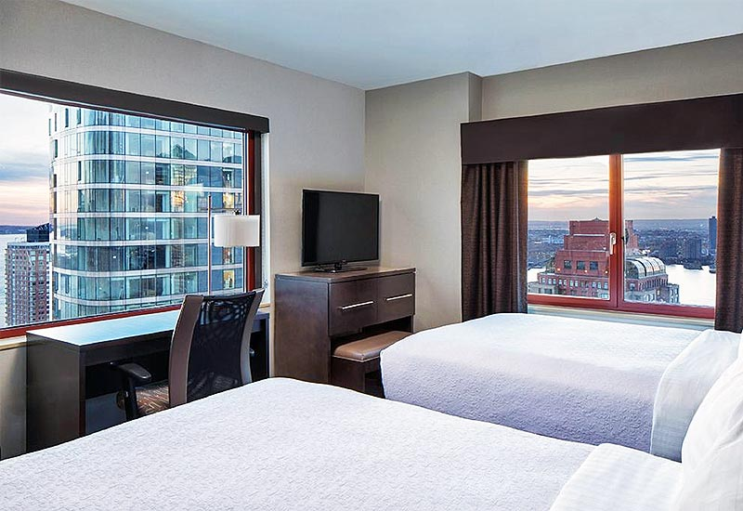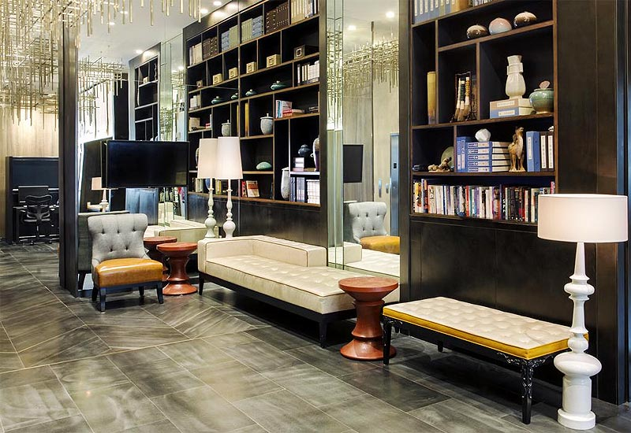

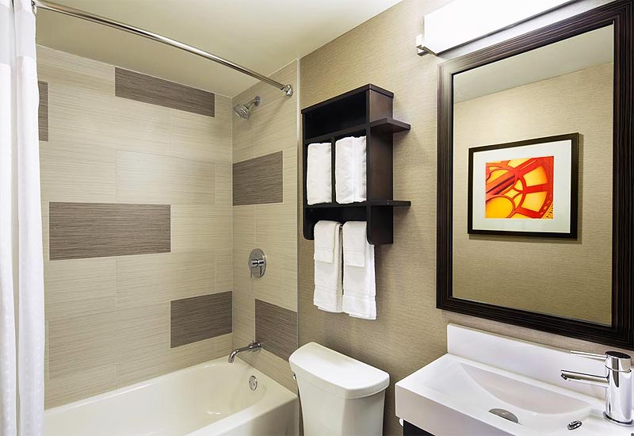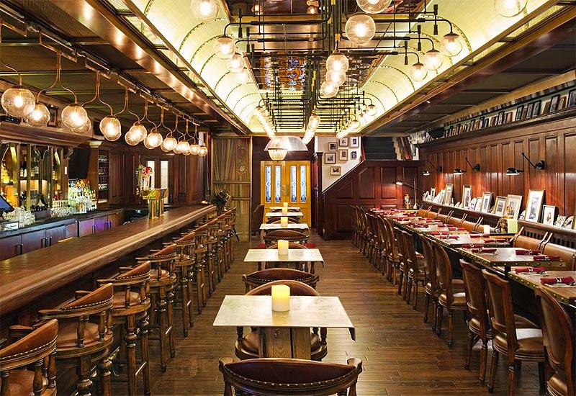
Holiday Inn Manhattan, Financial District 4*
www.hihotelmanhattan.com

